Facts for the trade press
Surface improvement with mass finishing

Walther Trowal:
Automatic cleaning and recycling of the process water saves time and costs
Integrated displacement-force measurement allows automatic machine setup.
Haan, Germany, December 12, 2023. In conjunction with surface finishing operations for metallic work pieces the new automatic cleaning centrifuge ZA 04 practically eliminates manual setup operations and drastically reduces maintenance work. In addition, the new machine requires about 30 % less space than its predecessor model.
In surface finishing operations the process water coming from mass finishing machines is contaminated with fines from the work pieces and the processing media. In addition, it can contain oil and grease carried into the machine by the work pieces. Before the process water can be re-used in the finishing operation or charged to drain, it must be cleaned by removing all contaminants. To save water, in most mass finishing operations the process water is re-used in a closed-loop recycling system. However, before it can be used again, the process water must be cleaned in a centrifuge. Centrifuges are equipped with a drum that rotates at high speeds. Due to the generated centrifugal force of the rotating drum the solids contained in the process water are deposited on the inner drum wall in the form of sludge. In case of higher sludge quantities that cannot be handled by manual emptying of the drum, so-called peeling centrifuges are utilized. These machines are equipped with a peeling knife that automatically discharges the sludge from the drum.
Walther Trowal has equipped the new, compact peeling centrifuge ZA 04 with an integrated displacement-force measurement system that digitally controls the movement of the peeling knife. This ensures that – depending on the thickness of the sludge layer – the peeling knife always has the right distance to the inner drum wall. Moreover, it allows the automatic setup of the machine by practically eliminating mechanical calibration operations, which to date had to be done manually at regular time intervals. This reduces the workload and time requirements for the mechanical setup of the peeling knife and the required maintenance to practically zero. In the past the calibration of the peeling knife always required a manual procedure. This is now automatically done by the new machine.
Besides this innovative digital setup procedure the Walther Trowal engineers have made the new centrifuge more compact: It requires about 30 % less space than its predecessor model. Moreover, all operational and maintenance elements can be accessed from one side. This saves not only valuable manufacturing space for the user but also provides a much greater degree of freedom for the placement of the machine on the manufacturing floor.
Operation by touch screen with the typical “Look and Feel” feature of the Trowal equipment is intuitive. In addition, it is a valuable diagnostic tool.
Contact:  Walther Trowal GmbH & Co. KG  Georg Harnau  Rheinische Straße 35-37  42781 Haan/Germany  Tel: +49 2129 571-209  www.walther-trowal.com  g.harnau@walther-trowal.de | Contact for the editor:  VIP Kommunikation  Dr.-Ing. Uwe Stein  Dennewartstraße 25-27  52068 Aachen/Germany  Tel: +49 241 89468-55  www.vip-kommunikation.de  stein@vip-kommunikation.de
Photos
Download of the high solution photos: press photos Walther Trowal
Photo 1: The new peeling centrifuge runs automatically and has a very small footprint.  File name:  Trowal-ZA04-0466-Gesamtansicht-Wagen.jpg | 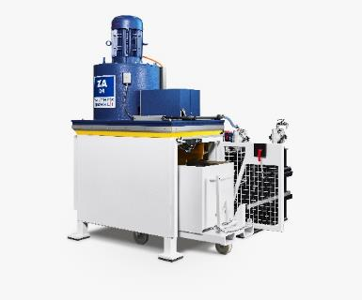
Photo 2: The digitally controlled peeling knife removes the sludge from the inner wall of the rotating drum.  File name:  Trowal-Zentrifugen_01.30.000.jpg | 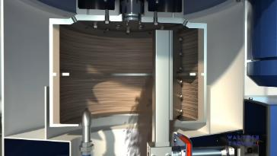
Photo 3: All operational and maintenance elements can be accessed from one side.  File name:  Trowal-ZA04-0466-Gesamtansicht-Wagen-Person.jpg | 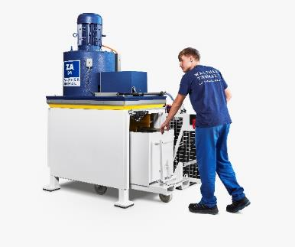
Photo 4: One peeling centrifuge (left) is cleaning and recycling the process water from two mass finishing rotary vibrators (right).  File name:  Trowal Kreislaufsystem Zentrifuge.jpg | 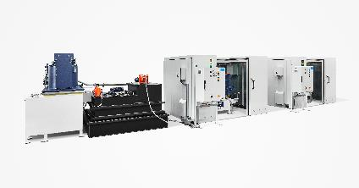
Copyright photos: Company photos Walther Trowal
About Walther Trowal
Surface finishing technologies from the inventor of the “Trowalizing” process
Since 1931 Walther Trowal has been developing and producing systems for the refinement of surfaces. Initially focusing exclusively on mass finishing – the term “Trowalizing” originated from the company’s cable address “Trommel Walther” – Walther Trowal has continuously expanded its product portfolio.
Over time the company has developed a broad range of machinery and systems for mass finishing, shot blasting and coating of mass-produced small components.
With the invention of new systems like, for example, drag finishing and the development of special finishing methods for 3D printed components, the company has proven its innovative capabilities again and again.
Walther Trowal develops and implements complete surface treatment solutions that can be seamlessly integrated into linked production systems existing at the customers. This includes the entire process technology, perfectly adapted to the specific surface finishing requirements of the work pieces: Equipment and the respective consumables always complement each other in a perfect manner.
Each individual work piece and each manufacturing process must meet special technical requirements. That is why the experienced process engineers in our test lab, in close cooperation with the customers, develop the optimal process technology for the finishing task at hand. The result: Work piece surfaces that meet exactly the required specifications … with short processing times and a high degree of consistent, repeatable results.
Walther Trowal is one of the few manufacturers who develops and produces all machines and mass finishing consumables in-house … including ceramic and plastic grinding and polishing media as well as compounds.
The company’s equipment range also includes all kinds of peripheral equipment for handling the work pieces like lift and tip loaders, conveyor belts and roller conveyors, in addition, special driers for mass finishing applications and, last-but-not-least, systems for cleaning and recycling of the process water.
With its exchange program for wear items like work bowls, which are part of a continuous recycling program, Walther Trowal conserves valuable resources and, thus, makes a significant contribution towards sustainability in the field of industrial production. Quick technical support and the global repair and maintenance service ensure high uptimes for our equipment.
Walther Trowal serves customers in a wide range of different industries all over the world, for example, automotive, aerospace, medical engineering and wind power.

